Avoir beau
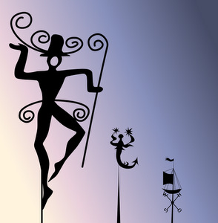
Share / Tweet / Pin Me!

Vain French Expression
Meaning | to do in vain, whatever one does
Literally | to have beautiful
Register | normal
Usage notes: The French phrase avoir beau might seem odd, as it uses avoir (to have) plus an action verb in the infinitive, but this is the most common way to express doing something in vain in French.
Par exemple…
J’ai beau dire la vérité, personne ne me croit. |  | I’m telling the truth, but in vain: no one believes me.
Elle a beau protester, le contrat va être annulé. |  | No matter how much she protests, the contract is going to be cancelled.
Avoir beau is often used to make general statements of impotence, with the indefinite pronoun on:
On a beau essayer, on ne peut pas le faire. |  | Try as we might / No matter how much we try, we can’t do it.
On a beau résister, la construction continue. |  | However much we resist, the construction (nonetheless) continues.
Note that the main verb is always an infinitive, not a past participle; the latter would create a phrase with the passé composé modified inexplicably by beau.
Also remember that because the infinitive and past participle of -er verbs sound the same, you might be tempted to consider some of the above examples as past actions, but they’re not: avoir is in the present, which means the vain acts are too. To talk about a vain attempt in the past, avoir itself needs to be conjugated into the passé composé:
J’ai eu beau chercher une jolie girouette, elles sont trop chères. |  | I looked in vain for a nice weather vane, but they’re too expensive.
Elle a eu beau protester, le contrat a été annulé. |  | No matter how much she protested, the contract was (nonetheless) cancelled.
Synonyms
- faire en vain
- faire inutilement

