THE AXIS LAWS
Posted on February 17, 2017 by dirkdeklein under History, Holocaust, Nuremberg Laws, Pre WWII, World War 2
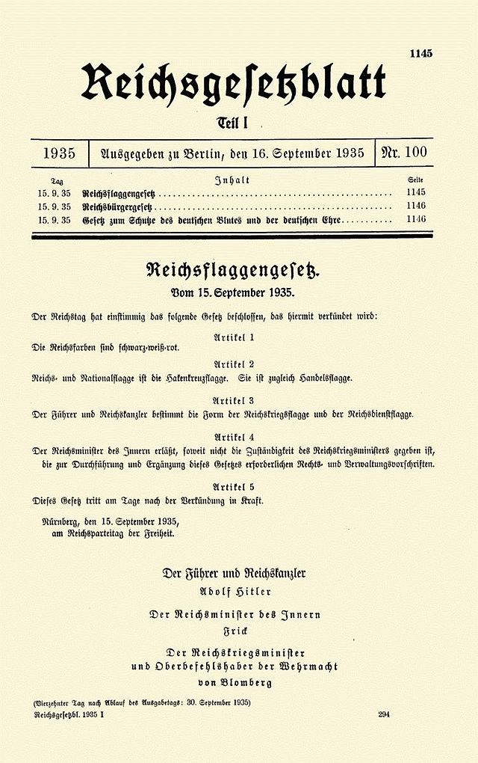
The Nuremberg Laws (German: Nürnberger Gesetze) were antisemitic laws in Nazi Germany. They were introduced on 15 September 1935 by the Reichstag at a special meeting convened at the annual Nuremberg Rally of the Nazi Party (NSDAP).
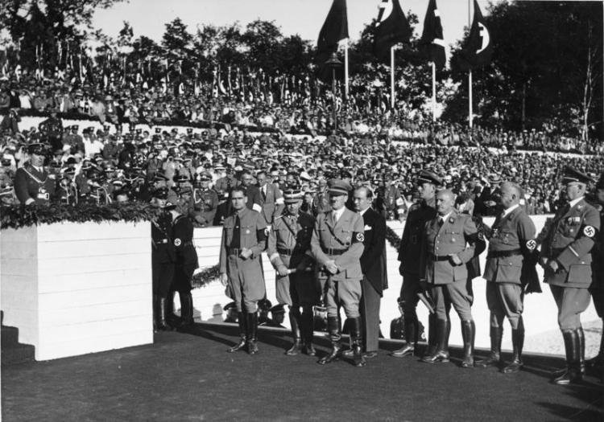
The two laws were the Law for the Protection of German Blood and German Honour, which forbade marriages and extramarital intercourse between Jews and Germans and the employment of German females under 45 in Jewish households, and the Reich Citizenship Law, which declared that only those of German or related blood were eligible to be Reich citizens; the remainder were classed as state subjects, without citizenship rights.
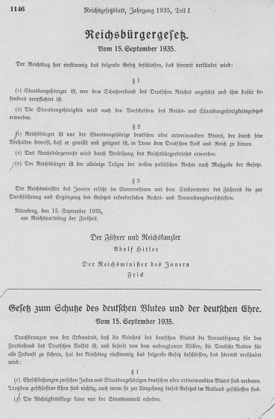
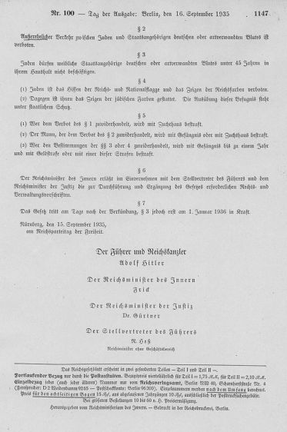
However the Nuremberg laws were not the only laws imposed. Most of Germany’s allies had their antisemitic laws.

Italy
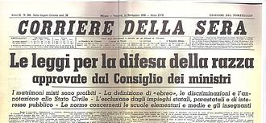
Le Leggi razziali: were a set of laws promulgated by Fascist Italy from 1938 to 1943 to enforce racial discrimination in Italy, directed mainly against the Italian Jews and the native inhabitants of the colonies.
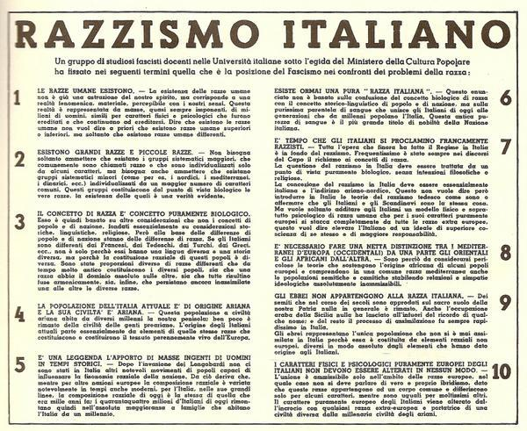
The first and most important of the leggi razziali was the Regio Decreto 17 Novembre 1938 Nr. 1728. It restricted civil rights of Jews, banned their books and excluded Jews from public office and higher education. Additional laws stripped Jews of their assets, restricted travel and finally provided for their internship in internal exile, as was done for political prisoners.
The promulgation of the racial laws was preceded by a long press campaign and by publication of the “Manifesto of Race” earlier in 1938, a purportedly-scientific report by fascist scientists and supporters that asserted racial principles, including the superiority of Europeans over other races. The final decision about the law was made during the meeting of the Gran Consiglio del Fascismo, which took place on the night between 6 and 7 October 1938 in Rome, Palazzo Venezia.
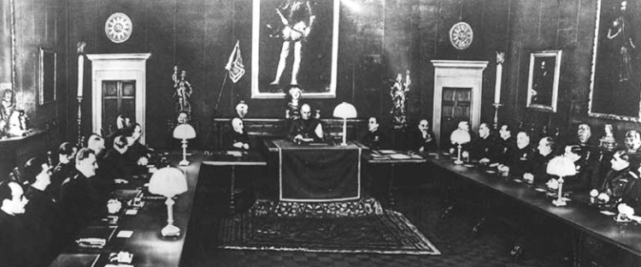
Not all Fascists supported discrimination: while the pro-German, anti-Jewish Roberto Farinacci and Giovanni Preziosi strongly pushed for them, Italo Balbo strongly opposed the laws.The Italian Racial Laws were unpopular with most ordinary Italians; the Jews were a small minority in the country and had integrated deeply into Italian society and culture
After the fall of Benito Mussolini on July 25, 1943, the Badoglio government suppressed the laws. They remained in force in the territories ruled by the Italian Social Republic until the end of the war (and were made more severe).

Bulgaria
Law for Protection of the Nation
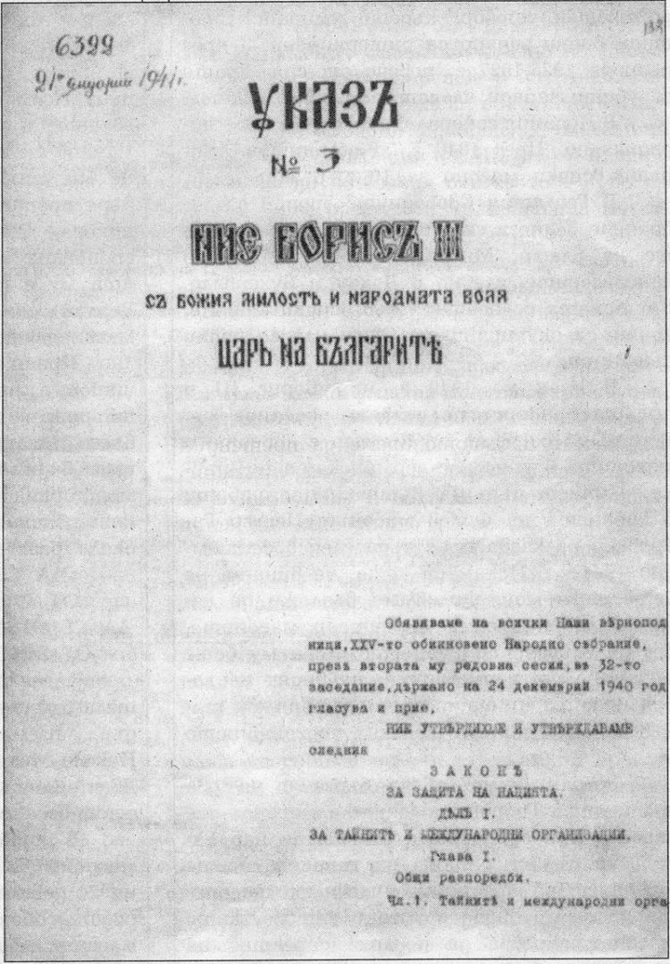
The Law for protection of the nation was a Bulgarian law, effective from 23 January 1941 to 27 November 1944, which directed measures against Jews and others. This law was passed along the example of the Nuremberg Laws.
The law ordered measures for:
- Changes in the names of Jews
- Rules about their place of residence
- Confiscation of their possessions
- Their exclusion from the public service
- Prohibition of economic and professional activity
Citizens of Jewish origin were also banned from certain public areas, restricted economically, and marriages between Jews and Bulgarians were prohibited. Jews were forced to pay a one-time tax of 20 percent of their net worth The legislation also established quotas that limited the number of Jews in Bulgarian universities.Jewish leaders protested against the law, and the Bulgarian Orthodox Church, some professional organizations, and twenty-one writers also opposed it.
This law suppressed all Freemasonry lodges and all other secret organizations.
The Law for protection of the nation, was passed under direct influence from Nazi Germany, but did not lead to the deportation of the Bulgarian Jews to Nazi extermination camps, except for the Jewish people from former Greek and Yugoslavian territories occupied by Bulgaria.

France
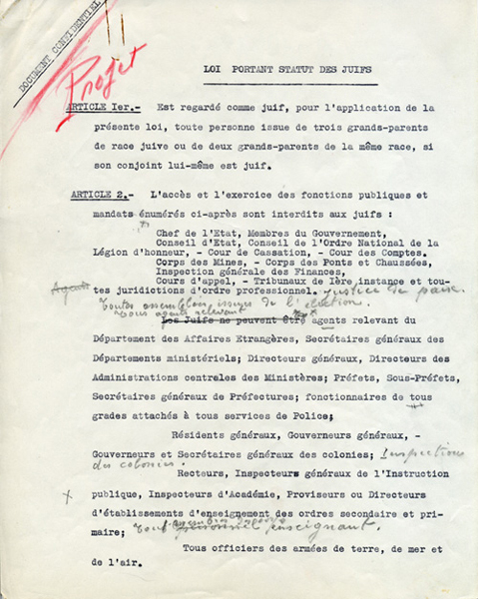
Anti-Jewish laws were enacted by the Vichy France government in 1940 and 1941 affecting metropolitan France and its overseas territories during World War II. These laws were, in fact, decrees of head of state Marshal Philippe Pétain, since Parliament was no longer in office as of 11 July 1940.
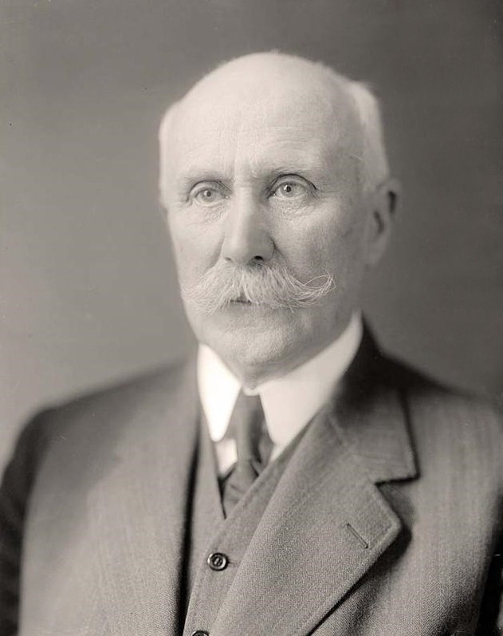
The motivation for the legislation was spontaneous and was not mandated by Germany. These laws were declared null and void on 9 August 1944 after liberation and on the restoration of republican legality.
The statutes were aimed at depriving Jews of the right to hold public office, designating them as a lower class, and depriving them of citizenship. Jews were subsequently rounded up at Drancy internment camp before being deported for extermination in Nazi concentration camps.
The denaturalization law was enacted on 16 July 1940, barely a month after the announcement of the Vichy regime of Petain. On 22 July 1940, the Deputy Secretary of State Raphaël Alibert created a committee to review 500,000 naturalisations given since 1927.
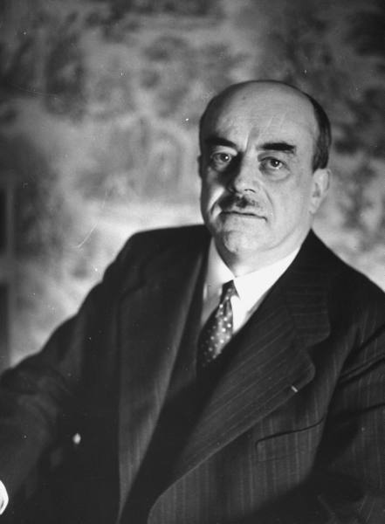
This resulted in 15,000 people having their French nationality revoked, of whom 40% were Jews. Alibert was the signatory of the Statutes on Jews.

Romania
In August 1940, the Romanian government passed legislation that Jews who converted to Christianity would be regarded as Jews for legal purposes, and barred from marriage with ethnic Christians; by defining Jews not based on religion this was the first step, and a large one at that, to further racial legislation.
Nuncio to Bucharest Andrea Cassulo’s “early efforts on behalf of Jews concerned almost exclusively those who had been baptized Catholic”
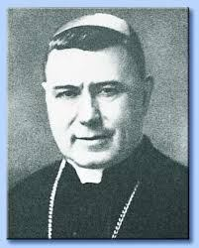
He passed on to the Vatican in 1939, but did not pursue, a project to emigrate the 150,000 converted Jews of Romania to Spain.From 1940 to 1941, his primary diplomatic responsibility was to protest various pieces of legislation insofar as they infringed on the rights of baptized Jews, particularly with respect to intermarriage and attendance of baptized Jews to Catholic schools, which were protected by the Romanian concordat.
Cassulo made three protests to Ion Antonescu: on November 20, 1940, December 2, 1940, and February 14, 1941.
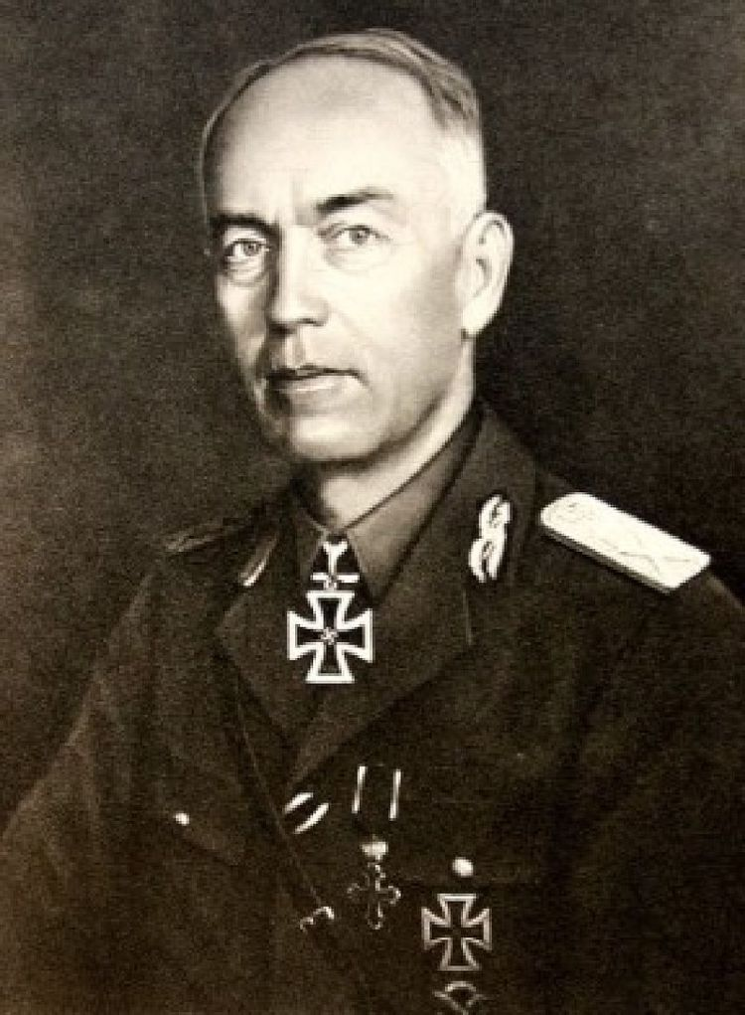
Five days after the last protest, Antonescu informed the nuncio of his signing a decree allowing students of any ethnic origin to attend their own religious schools.
However, “much more worrisome to the Vatican” was a March 18, 1941, decree forbidding the conversion of Jews to Christianity, with severe penalties for Jews attempting to convert and cooperating priests. Again, Cassulo protested that this violated the concordat, but the Romanian government replied that the decree did not because it would only affect the “civil status” of baptized Jews.Bypassing the “blatant racism” of this reply, Maglione’s “sole interest” was that the rights of the concordat be extended to baptized Jews. The Vatican considered the matter settled after a July 21, 1941, note from the minister of foreign affairs granted the enumerated demands of Maglione: “free profession of the Catholic faith, admission to Catholic schools, religious instruction, and spiritual assistance in various areas of society.
Most of the other Axis countries adopted laws based on the Nuremberg laws.


