https://www.theguardian.com/books/2017/jan/13/china-rewrites-history-books-to-extend-sino-japanese-war-by-six-years
In a move expected to anger Japan, government orders amendment of school texts to move back war’s official outbreak from 1937 to 1931

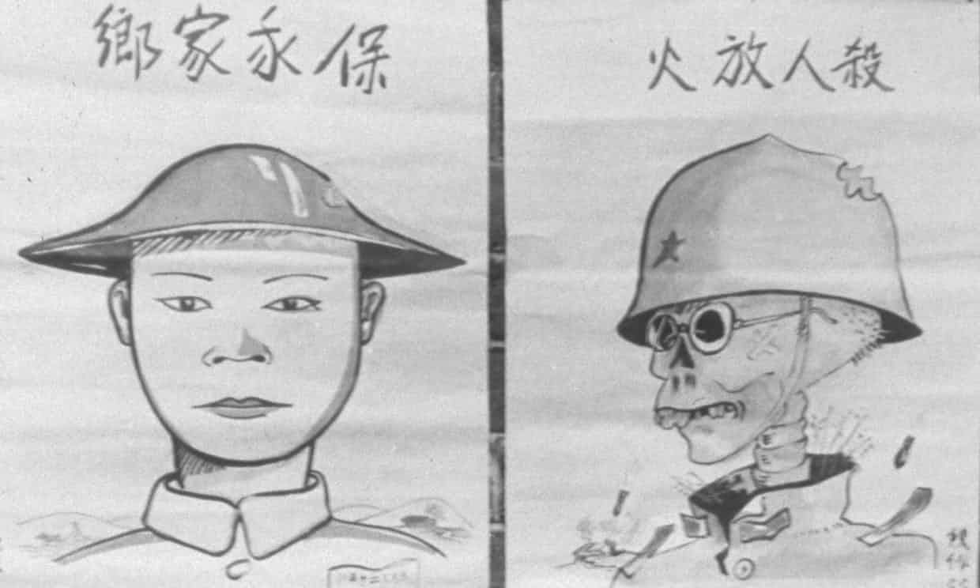

Chinese propaganda posters photographed during the Sino-Japanese war. Photograph: Hulton Archive/Getty Images

- China’s government has ordered that all Chinese history textbooks be rewritten to extend the second Sino-Japanese war by six years, a move likely to inflame relations with Japan.The conflict, which has been known for generations in China as the “eight-year war of resistance against Japanese aggression”, is usually recorded as starting in 1937 and ending in 1945. However, in a statement on Wednesday, President Xi Jinping’s government renamed the conflict the “14-year war of resistance against Japanese aggression” and has ordered that textbooks be revised to record it as lasting from 1931 until 1945.
The decision means China officially considers that the second Sino-Japanese war started in autumn of 1931, when the Imperial Japanese army invaded Manchuria, rather than six years later during the Marco Polo Bridge incident, when Japanese and Chinese troops fought along a rail line south-west of Beijing. Historians have traditionally considered this event everywhere as the start of full-scale conflict between the two countries. In recent years, President Xi has worked hard to promote the achievements of the communists during the second world war, despite many historians arguing that it was the Chinese nationalist party, not the communists, who did most of the fighting and led efforts to negotiate a truce with Japan before 1937.
The Communist party has not previously emphasized its role in the country’s conflict with Japan before 1937, a period when communist forces were engaged in a civil war with the Kuomintang nationalists, led by Chiang Kai-shek. It was not until 1937 that the communists and nationalists joined forces to fight the Japanese army.
Historian Antony Beevor told the Guardian that while there has long been a debate about the start of the war, China’s decision to revise the dates “does show weakness rather than strength”.
“The Communist party did very little to resist the Japanese during 1931-37, so why try to pretend otherwise? I can only imagine that this is an attempt to reverse the recent tide of historiography, which has recognised that Chiang Kai-Shek and the nationalists had been very unfairly treated not just by Chinese communist dogma, but also by the US administration and journalists of the time,” he said.
Beevor, whose book The Second World War begins with Japan’s invasion of Manchuria in 1931, said it was hard to tell how Japan would react.
“The invasion of Manchuria was brutal colonialism, but the Sino-Japanese war from 1937 was a semi-genocidal war, comparable only to Hitler’s invasion of the Soviet Union,” he said.
Zhang Lifan, a historian in Beijing, told the New York Times that while revising the dates was justified in terms of historical accuracy, the decision would have been motivated by the possible political benefits for the Communist party and may encourage anti-Japanese sentiment.
“Chinese leaders still have a cold war mentality,” he said. “They’ve tried to conjure up imaginary enemies in the world.”
Yasuhisa Kawamura, press secretary for the Japanese ministry of foreign affairs, said on Thursday that China did not have the power to decide when the conflict started. “It is important that Japan and China should demonstrate they do not focus excessively on the unfortunate past,” he said.
Japan’s government has been criticised in the past for attempts to revise school textbooks to remove or downplay instances of Japanese military aggression, which critics fear may push the country farther from its postwar pacifism. In 2007, Shinzo Abe’s conservative government ordered history books change all references to forced suicides during the second world war.In 2013, plans were mooted that would require all Japanese textbooks to include viewpoints of nationalist scholars on contentious historical data, including the death toll of the 1937 massacre in Nanking of Chinese civilians by Japanese soldiers. China’s official estimate is 300,000, but most Japanese scholars say that figure is a vast exaggeration.

