Giggling over genocide: They flirted with the SS, wore pink underwear and even had a hair salon - the female death camp guards as evil as the men
- More than 50,000 women slaughtered at concentration camp Ravensbruck
- It was Hitler's biggest all-female death camp, located in northern Germany
- Pretty female guards with fashionable hair would release dogs on inmates
- One guard, known as ‘beautiful bitch’, had penchant for torturing pisoners
- ‘Her eyes shone when she beat people,’ said one survivor 70 years later

More than 50,000 women were slaughtered in the Nazi concentration camp of Ravensbruck. Now, the horrors of Hitler’s biggest all-female death camp have been detailed in a brilliant new book, based on the chilling testimonies of the prisoners. On Saturday, we told how they suffered horribly for not conforming to the Nazi ideal of womanhood. Here, in our final extract, we tell what sort of women became camp guards . . .
Just before the hood was put over her head, the noose tightened and the trap-door beneath her sprung, Dorothea Binz, one of the most loathed and loathsome of the SS women guards at Ravensbruck concentration camp, uttered her last words.
‘I hope you won’t think that we were all evil people,’ she said as she took off her necklace and handed it to her executioner.
It was a bewildering statement given that, for the tens of thousands whose lives she had made a living hell and whose hideous deaths she was responsible for, she was the very personification of evil.
It also failed to address a question that still hangs over the grim history of the only German camp exclusively for women, where up to 50,000 were murdered and twice as many tortured.
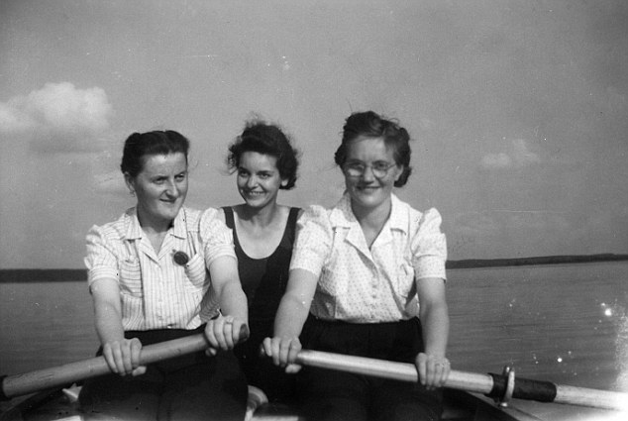

Evil: Ravensbruck concentration camp guards Helene Massar, Marga Löwenberg and one other out rowing on the Schwedtsee lake
What sort of women was capable of committing such terrible atrocities against other women?
The usual answer is to portray women guards as more like surrogate men.
In reality, they were far from lacking in femininity. Many were blonde and beautiful, and, in their mouse-grey jackets, culotte-style skirts, caps and leather boots, they were the envy of other girls in the nearby town of Furstenberg.
Off duty, they picked flowers in the forest, went boating on the lake, partied and flirted (and more) with the dozen or so male SS guards in the camp.
One picture from that time shows three girls, giggling in a rowing boat. They were all guards — one of them, Helene Massar, in charge of the camp’s sewing workshop, was known as a brute, while another was Marga Lowenberg, whose pretty features belied the horrific treatment she handed out to prisoners.
The camp even had its own hair salon, where hairdressers from among the prisoners would pamper guards. Like women everywhere, they sat and chatted among the driers while their hair was styled, mainly in a fashionable Olympia roll in which the hair was swept up and back. Then they went back to snarling and screaming, wielding whips and letting loose their dogs on inmates.
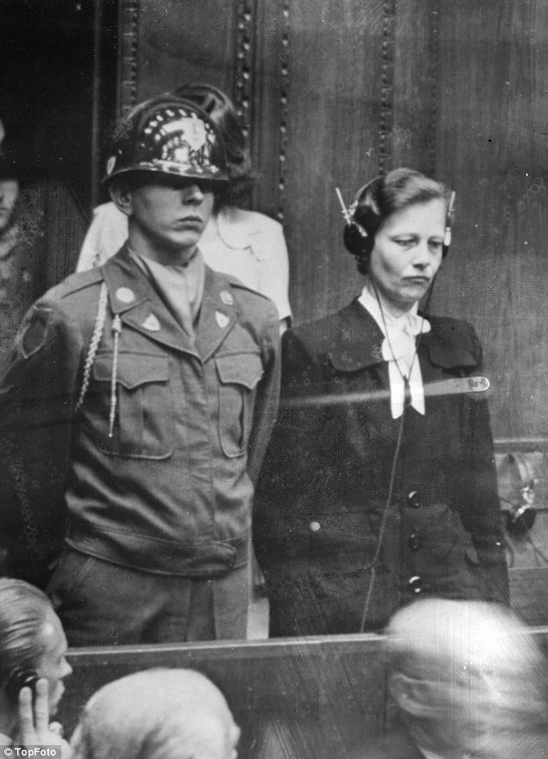
Trial: Dr Herta Oberheuser from Stocksee North West Germany is flanked by a US guard on trial for war crimes at Ravensbruck concentration camp in February 1958
Some 3,500 women guards worked there over Ravensbruck’s six gruesome years, and some were troubled by the more extreme horrors they witnessed.
Johanna Langefeld, the very first Oberaufseherin (head guard), had no qualms about imposing brutal discipline and keeping prisoners standing in the cold and rain for hours on end.
But she drew the line at formal floggings and was appalled by vivisection medical experiments on inmates — or ‘the rabbits’ as they were known. She lost her position for being soft on a near-mutiny by Polish prisoners over this issue.
Her secretary, an inmate, remembered times when her boss was depressed, ‘torn’ between right and wrong and having terrible nightmares.
However, the elegant and naturally blonde-haired Binz — the ‘beautiful bitch’, as she was known, with her rounded cheeks and upturned nose — was cut from different cloth.
She was in charge of the bunker, the camp’s punishment block, and enjoyed handing out beatings and torturing the inmates by dousing them in icy water. They quickly learned to avoid her eyes.
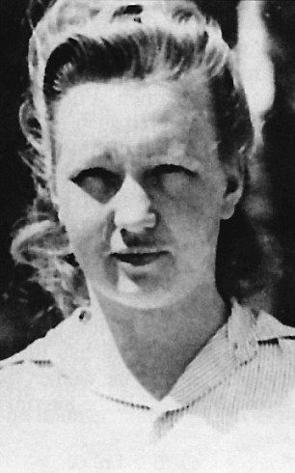

Sadist: Dorothea Binz, who became chief of Ravensbruck, enjoyed handing out beatings and torturing the inmates
She was particularly hard on Red Army prisoners, the ‘Russian swine,’ as she called them. One of them wrote a poem about her that was hidden away for 70 years until it was read to me in the Moscow apartment of a survivor. It went:
‘A beautiful blonde,
You are so beautiful,
With shining blue eyes and locks of hair,
But if we could, we would tear the insides of your soul
And strangle your bloodthirsty heart.’
She was a sadist, a survivor told me. ‘Her eyes shone when she beat people.’
One of the earliest prisoners in Ravensbruck was Doris Maase, a Left-wing German doctor, whose first sight of Binz was when an inmate tried to kill herself by running onto the electric fence.
Binz stopped her. ‘She dragged the skeletal woman away and beat her with a cane on her naked thighs. Such cruelty in one so young and pretty made a lasting impression on me.’
Binz’s appetite for cruelty soon made an impression on everyone. And yet, until she got the job there, she had been little noticed and there had been no indication of the extreme violence in her nature.
The daughter of a forester, she grew up in the woods around Furstenberg, attending village schools and churches, playing down forest trails, chasing wild pigs, bathing in lakes in the summer, skating on them in winter.
Significantly, work at the camp was her first job. She was also young enough not to have much experience of life before Nazi rule. She took its doctrines as gospel. At ten, she and her friends joined the League of German Girls, the female wing of the Hitler Youth. At school, she followed the Nazi curriculum, which taught children to despise Jews and revile society’s outcasts.
In her teens she went down with tuberculosis, spent months in a clinic and missed out on schooling. She left with few, if any, qualifications.
Stigmatised as a carrier of TB and barred from many jobs due to the danger of contagion, on leaving school she worked as a kitchen maid. When the chance came to become a guard at the new concentration camp opening nearby, aged 19, she jumped at it.
Later, as she rose up the ladder, she would laughingly relate how her father had told her not to take the job, but the opportunity to live away from home, in comfortable quarters, with good pay and a smart uniform was too good to turn down.THE ROOM WHERE BABIES WERE ABAN THE
There was also the prospect of meeting men. She was soon having an affair with a married SS officer.
Like all the women guards, she was classified as merely an SS auxiliary, subordinate to the men. On paper, none of them had any official standing. But she imbibed the SS mentality totally and, particularly, the idea that orders were sacrosanct and even the severest must be implemented.
She accepted without question that the job of a concentration camp guard such as her was to protect ‘the homeland’ against its internal enemies and that the fight against those in the camps was as important for the future of the Reich as the fight at the front.
Inflexible harshness towards prisoners was required. An old friend remembered looking closely at her when she came home to visit ‘and was astonished how her face had changed since she went to work there. It was harder and wizened somehow’.
Binz was far from alone in her cruelty. The special amusement of 23-year-old Maria Mandl — who replaced Langefeld as chief guard — was to hunt for any curled hair at roll-call. She would stride slowly along the rows of prisoners inspecting heads, and if she found a curly lock peeking from beneath a cap she would beat the woman to the ground.
She would send the offender to be shaved and then make her parade in front of others with a placard hanging from her neck: ‘I broke the rules and curled my hair’.
Without a second thought she kicked a Jewish woman to death at roll-call for some transgression. But shortly after, a strange thing happened, says prisoner Maria Bielicka.
‘A friend of mine had a job cleaning in the guards’ hostels, where there was a piano, and one day heard the most beautiful music. The woman playing was lost in ecstasy, in a world of her own. It was Mandl, who, just a few days earlier, had murdered the Jewish woman in front of us all.’
Mandl was soon promoted again: she was sent to Auschwitz, where she became chief of the women’s section.
It was the same with Binz. Here was a woman who ran after a truck taking away a group of prisoners to be hanged, calling: ‘Wait for me, wait for me, I want to come and watch.’
Yet she was devastated when her Alsation died and planted flowers on its grave. ‘She loved that dog,’ a survivor said, ‘but liked to beat people.’
As well as the guards, there were also brutes of women among the staff in the camp hospital.
In a see-through blouse over pink underwear, with gold bangles on her arms and rings on her fingers, the tall and blonde Dr Herta Oberheuser administered lethal injections when she felt like it, killing one teenager simply for wetting her bed. When patients complained of extreme thirst, the doctor provided water laced with vinegar.
Then there was Elisabeth Marschall, the head nurse, whose plump frame and cheery face gave her a cosy, maternal appearance as she cuddled and cooed over any babies born in the camp. Yet she stole large quantities of powdered milk, semolina and porridge from Red Cross parcels and kept them for herself while those same babies starved to death.
She, like most of the staff, felt justified in the cruelty they casually handed out. She accepted without question the Ravensbruck philosophy that the prisoners were a burden on the Fatherland.
Binz felt the same. She told an old school friend that the prisoners were all Godless criminals and prostitutes and treating them harshly was the only way to keep them in check.
Guard Ruth Neudeck’s excuse for whipping prisoners was that they were ill disciplined. As for the silver-handled riding crop she wielded, she justified its use on the grounds that ‘I couldn’t strike them with my hand because they were always infested with lice’.
Hideous explanations like this were put forward when just two dozen of the worst offenders were called to account at the end of the war.
The crimes they were accused of were so ghastly that one of the prosecution lawyers was physically sick when he first read through the evidence. Yet when Binz and others from Ravensbruck shuffled into the dock to be tried, it was their ordinariness that struck observers.
‘They might have stepped out of a bread queue in any German city,’ one writer declared.
That sentence helps answers the question of what sort of women were capable of committing such terrible atrocities: ‘ordinary’ ones like Dorothea Binz, given licence to be evil.
ROOM WHERE BABIES WERE ABANDONED TO DIE
In 1944 some women arriving at Ravensbruck were heavily pregnant and gave birth on the ground the moment they arrived.
But many others — perhaps as many as one in ten — were in the earlier stages of pregnancy, too, often as a result of being raped by enemy soldiers. These women were mostly Poles, rounded up and brought there after the Warsaw Uprising.
Until now birth was banned at the camp — anyone arriving pregnant was forced to undergo abortion. But suddenly there were simply too many babies to abort, so a room in the camp hospital was set aside for deliveries with a Czech prisoner doctor named Zdenka Nedvedova in charge and midwives to assist.
The first 20 babies to be born were well-treated. So were their mothers, who were allowed a glass of milk immediately after birth, mixed with oatmeal.
But within days, orders were given to stop the extra rations, and very quickly none of the mothers had any milk to speak of in their breasts, and the babies began to starve.
This was intentional. Heinrich Himmler’s SS, which ran the death camps, had no intention of letting the babies live. Starvation was considered the natural way.
The mothers went almost mad, pleading and screaming for help. So a new Kinder Zimmer — a babies’ room — was built in one of the accommodation blocks.
Babies were brought there as soon as they were born and laid out on two beds — head to toe, five one way, five the other, ‘like sardines’, as Marie-Jo Wilborts, the French prisoner in charge of them, said.
There were no longer any blankets, and inmates stole rags to wrap around them. After 30 days in these dreadful conditions, the first 100 were all dead.
In Paris, I interviewed Marie-Jo Wilborts, who did her best in impossible circumstances. When I asked her how she and the other baby nurses managed to carry on, she gave a sad smile. ‘We just hoped we might save some of them,’ she said.
She picked up an old ledger smuggled out of the camp that recorded every birth and death in the Kinderzimmer. She traced her finger across a page, showing the names of babies born. There were 600 in total born between September 1944 and April 1945, when the camp was liberated.
Of these, she told me, 40 survived, ‘but most of those were taken to Belsen in February 1945, where they too died’.

Giggling Over Genocide
- In your opinion what kind of women became Nazi guards?
- What kind of ideal Nazi woman do you imagine?
- What crimes against humanity did these women commit?
- How many female guards were there at Ravensbruck?
- What factors do you think might have nurtured the violence in those women?
- Who gave these “ordinary, out of bread queue “ women a license to kill?
- What significance does the Kinder Zimmer description play in the article?

