Unit Test 2 December 2 Review
For the review purposes for the essay-test please ensure the revision of the following:
- Causes and consequences of the Seven –year War (notes from the ppts, documentary notes(answers have been posted), the reading package from the ICA)
- Causes and outcomes of the American Revolution ( all the notes from class, ppts )
- Causes and Consequences of the War of Independence ( 1812-1815), all the notes in class, documentary ( Been there, Won that, ppt)
- Documents surrounding the above-mentioned wars( Treaty of Paris of 1763, Royal Proclamation, Treaty of Paris of 1783, the Constitutional Act of 1791, the Declaration of Independence, Decree of Berlin, Act of Quebec, Treaty of Ghent )
- You will be asked to complete two things
- To write an essay
- To write a self-reflection
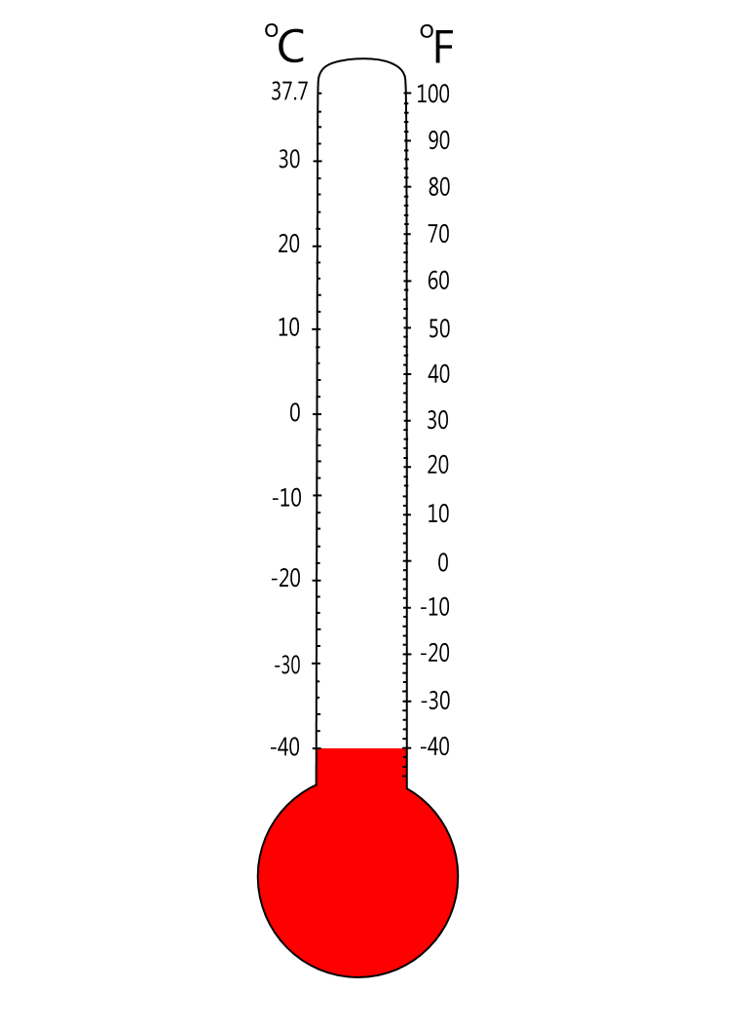
Vertvvvv
VerVeVVery r

Very Well

Neutral

Oops

